**EXPERIMENT 3**

**Name : Urvashi**

**SAP ID : 500083262**

**AIM: Working with Docker Volume**

Steps to Complete:

1. View all Volume in Docker

**Command : docker volume ls**

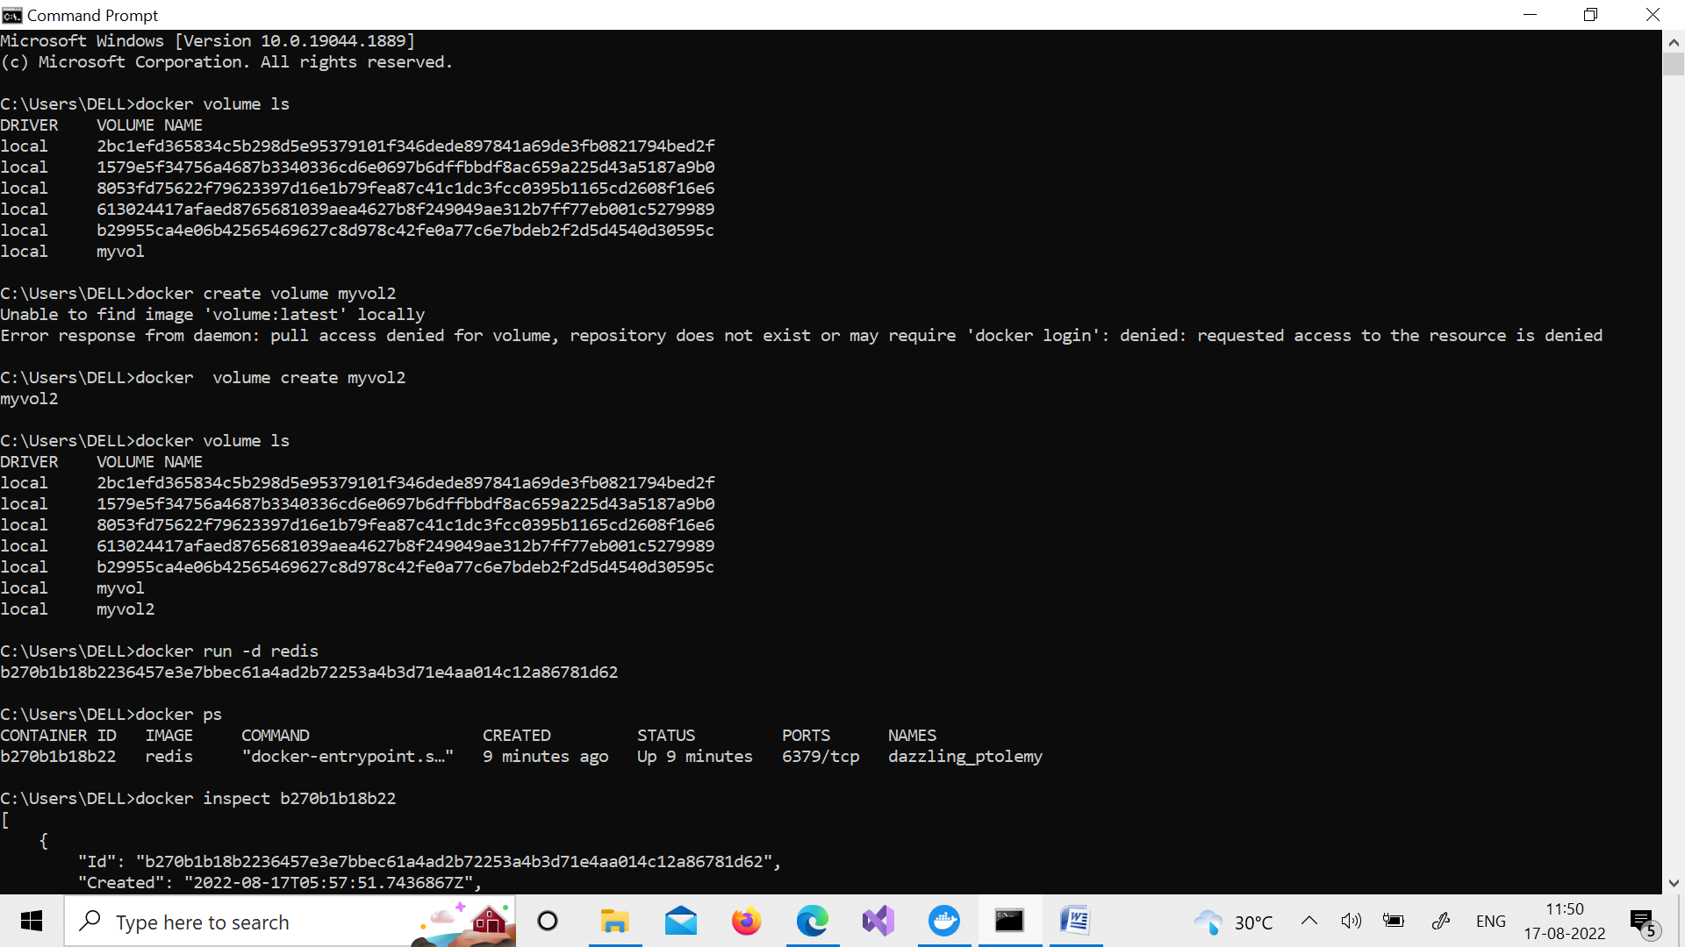

1. Create a new Volume

**Command : docker volume create myvol2**

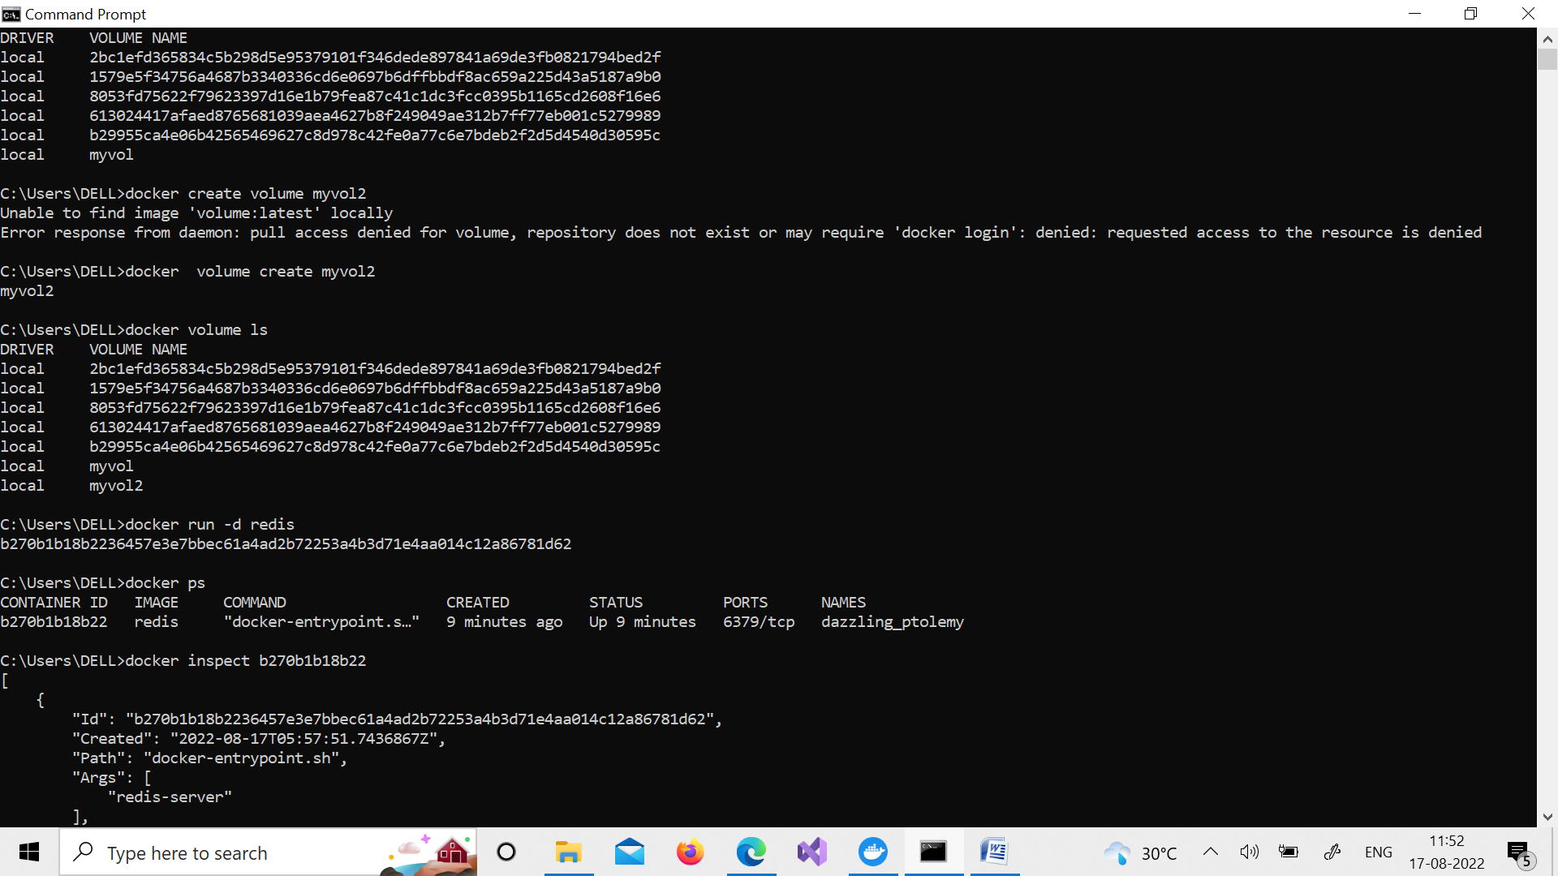

1. Mount a Volume with a container

**Command : docker run –it –v myvol2:/data redis /bin/bash**

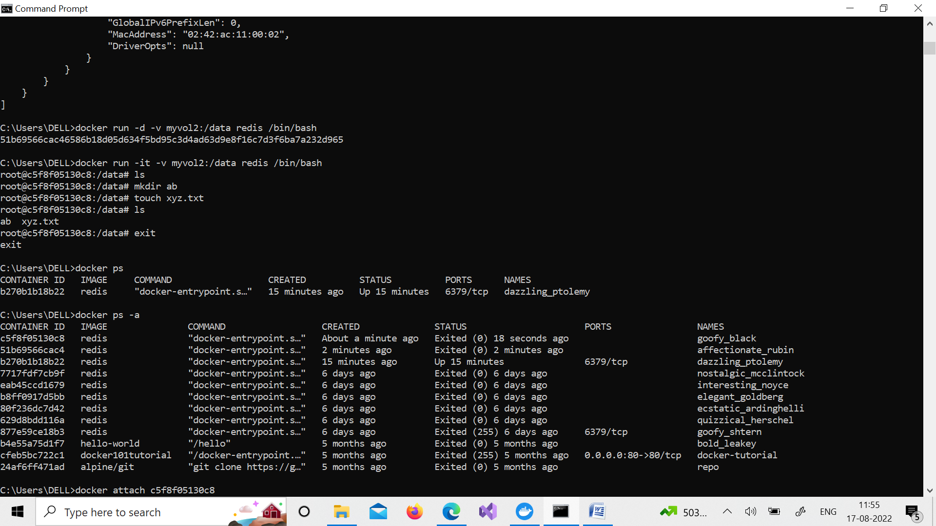

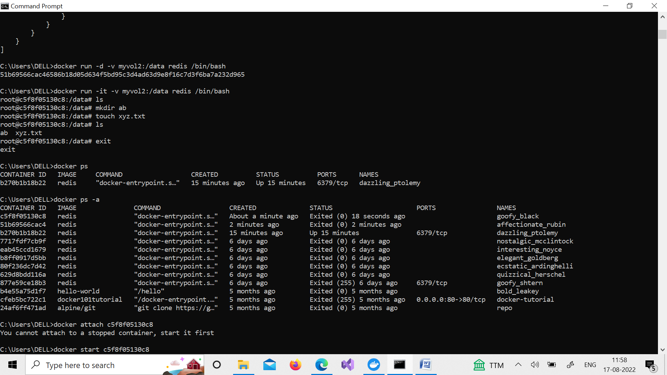

1. Create another container and Mount with the same Volume

**Command : docker run –it –v myvol2:/data redis /bin/bash**



1. See the complete working of container



6. Exited from container and restart again to see the persistent of Docker

**Command : docker start c5f8f05130c8**

**docker attach c5f8f05130c8**

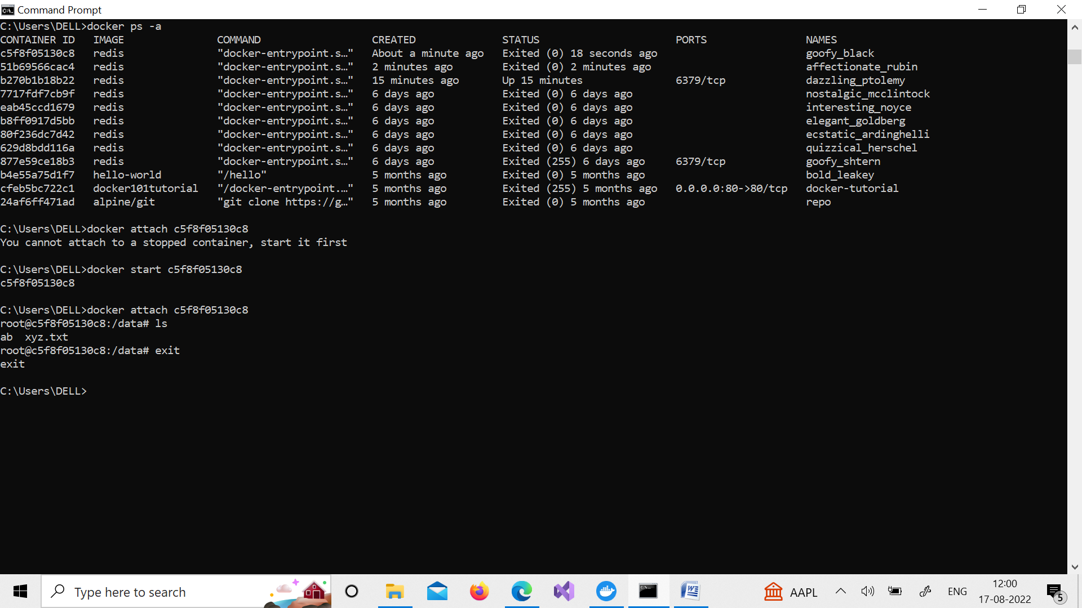

commands :

**docker volume ls**

**docker create volume myvol2**

**docker volume ls**

**docker run -d redis**

**docker ps**

CONTAINER ID IMAGE COMMAND CREATED STATUS PORTS NAMES

b270b1b18b22 redis "docker-entrypoint.s…" 9 minutes ago Up 9 minutes 6379/tcp dazzling_ptolemy

**C:\Users\DELL>docker inspect b270b1b18b22**

**C:\Users\DELL>docker run -d -v myvol2:/data redis /bin/bash**

51b69566cac46586b18d05d634f5bd95c3d4ad63d9e8f16c7d3f6ba7a232d965

**C:\Users\DELL>docker run -it -v myvol2:/data redis /bin/bash**

root@c5f8f05130c8:/data# ls

root@c5f8f05130c8:/data# mkdir ab

root@c5f8f05130c8:/data# touch xyz.txt

root@c5f8f05130c8:/data# ls

ab xyz.txt

root@c5f8f05130c8:/data# exit

exit

**C:\Users\DELL>docker ps**

CONTAINER ID IMAGE COMMAND CREATED STATUS PORTS NAMES

b270b1b18b22 redis "docker-entrypoint.s…" 15 minutes ago Up 15 minutes 6379/tcp dazzling_ptolemy

**C:\Users\DELL>docker ps -a**

CONTAINER ID IMAGE COMMAND CREATED STATUS PORTS NAMES

c5f8f05130c8 redis "docker-entrypoint.s…" About a minute ago Exited (0) 18 seconds ago goofy_black

51b69566cac4 redis "docker-entrypoint.s…" 2 minutes ago Exited (0) 2 minutes ago affectionate_rubin

b270b1b18b22 redis "docker-entrypoint.s…" 15 minutes ago Up 15 minutes 6379/tcp dazzling_ptolemy

7717fdf7cb9f redis "docker-entrypoint.s…" 6 days ago Exited (0) 6 days ago nostalgic_mcclintock

eab45ccd1679 redis "docker-entrypoint.s…" 6 days ago Exited (0) 6 days ago interesting_noyce

b8ff0917d5bb redis "docker-entrypoint.s…" 6 days ago Exited (0) 6 days ago elegant_goldberg

80f236dc7d42 redis "docker-entrypoint.s…" 6 days ago Exited (0) 6 days ago ecstatic_ardinghelli

629d8bdd116a redis "docker-entrypoint.s…" 6 days ago Exited (0) 6 days ago quizzical_herschel

877e59ce18b3 redis "docker-entrypoint.s…" 6 days ago Exited (255) 6 days ago 6379/tcp goofy_shtern

b4e55a75d1f7 hello-world "/hello" 5 months ago Exited (0) 5 months ago bold_leakey

cfeb5bc722c1 docker101tutorial "/docker-entrypoint.…" 5 months ago Exited (255) 5 months ago 0.0.0.0:80->80/tcp docker-tutorial

24af6ff471ad alpine/git "git clone https://g…" 5 months ago Exited (0) 5 months ago repo

C:\Users\DELL>docker start c5f8f05130c8

c5f8f05130c8

C:\Users\DELL>docker attach c5f8f05130c8

root@c5f8f05130c8:/data# ls

ab xyz.txt

root@c5f8f05130c8:/data# exit

exit